Name: Mai Tien Dat Tran

ID: 104207944

**Tic-Tac-Toe Game Outline Design**

**Introduction**:

Tic-Tac-Toe is a classic two-player game played on a 3x3 grid. The objective of the game is to place three of your markers ('X' or 'O') in a row, column, or diagonal on the grid. In this report, we will discuss the design and implementation of a Tic-Tac-Toe game using Python

1. **Design Overview:**

The game is implemented using object-oriented programming principles. The main components of the game include:

TicTacToe Class: Manages the game flow, player turns, and game logic.

RandomAI Class: Represents a simple AI player that makes random moves.

User Interface: Displays the game board and prompts players for input.

1. **Implementation:**

The TicTacToe class handles the game flow. It includes methods to display the game board, get player input, update the board, check for a win or draw, switch players, and set an AI player.

The RandomAI class represents a simple AI player that makes random moves on the board.

The game loop is managed by the play() method in the TicTacToe class. It displays the board, prompts the current player for input, updates the board, and checks for a win or draw until the game ends.

**3. Win Conditions:**

Define the criteria for winning the game, which involves having three identical symbols aligned in a row, column, or diagonal.

**4Player Interaction:**

Receive input from the user for their desired move, including the row and column. Ensure that the input is valid, confirming that it corresponds to an available space on the game board. Update the game board with the player's chosen move.

1. **End Game:**

Decide the conclusion of the game, signaling when it ends either due to a player achieving victory or the board reaching its maximum capacity (a draw). Present the ultimate configuration of the board. Declare the victorious player or acknowledge a draw. Inquire whether the players wish to commence a new game.

Random AI:   
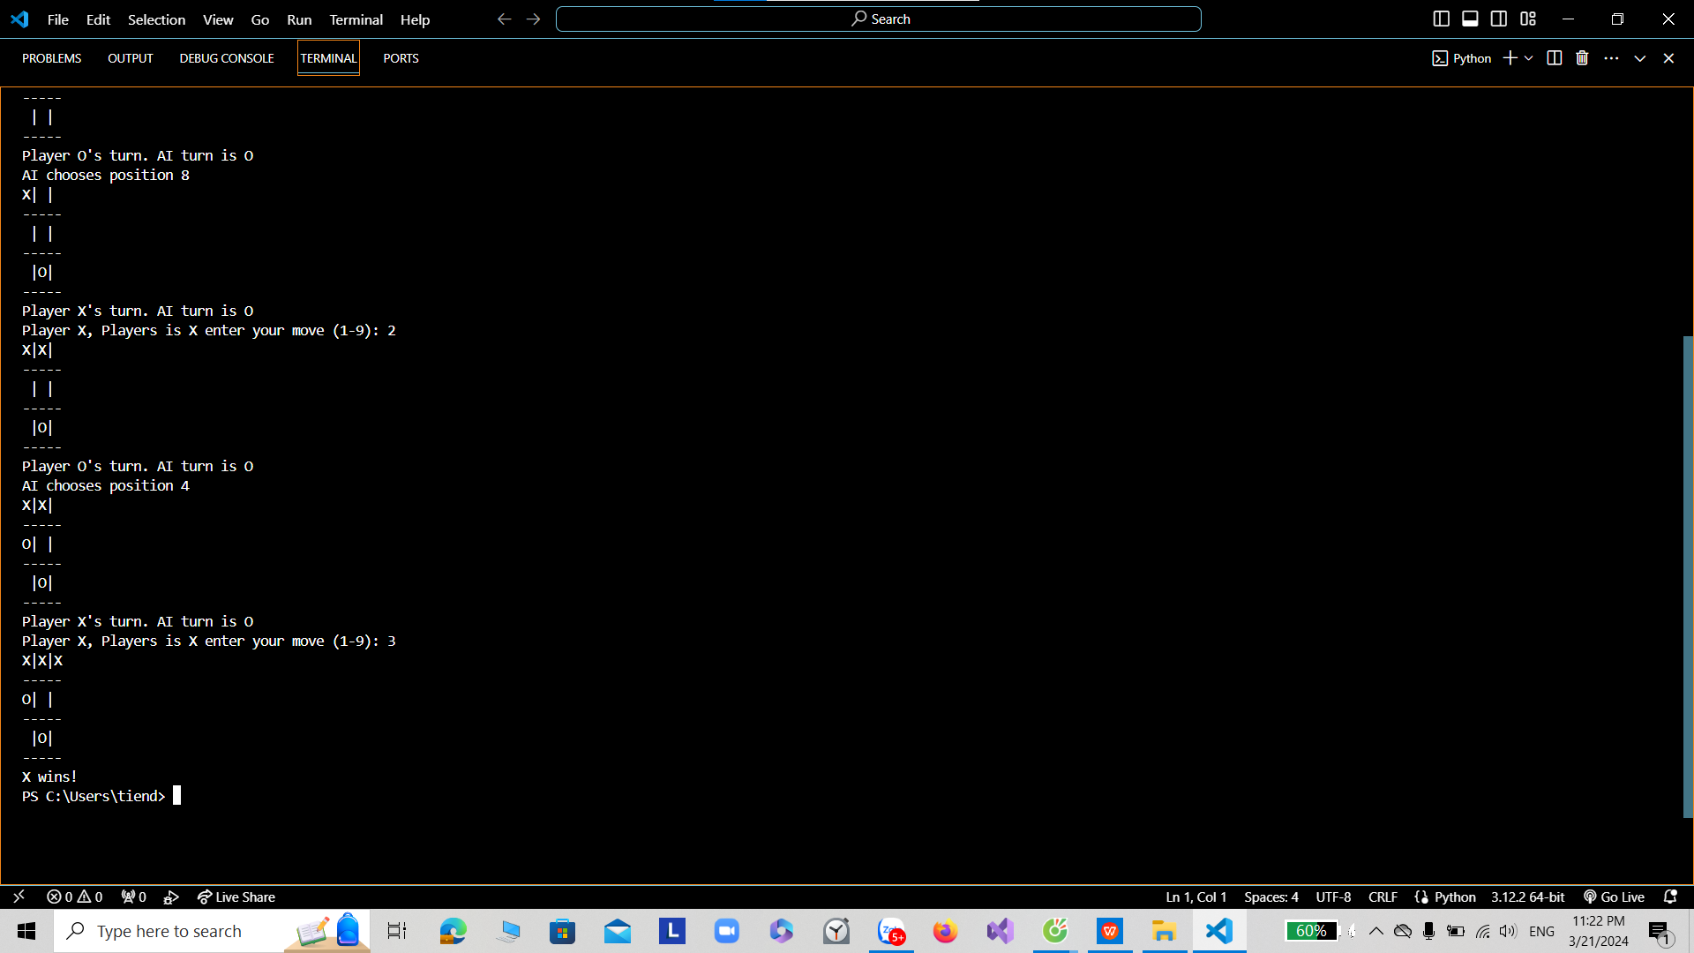

Minmax Ai:

